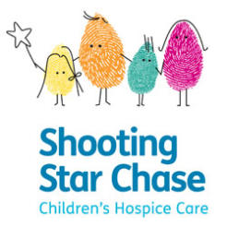
HOSPICE TO HOSPICE RUN
Saturday 18 May 2019
Starting at Phyllis Tuckwell Hospice, Farnham at 10.30am
Hart Road Runners is organising it’s annual Hospice to Hospice run from Phyllis Tuckwell Hospice in Farnham to The Shooting Star Chase Children’s Hospice in Arlington on Saturday 18th May 2019.
- The route will follow the North Downs Way, almost all of which is off-road and is about 10 miles.
- Tea and cakes on arrival at The Shooting Star Chase.
- The course is easy to follow, and maps will be available. No-one will get left behind.
- There is a ‘pit-stop’ at Puttenham (just over half way) with refreshments
- IT IS NOT A RACE
Parking is available at Phyllis Tuckwell for the start (in the School next door) and in the Park and Ride carpark at Arlington (next door to the Shooting Star Chase)
Participants need to arrange their own return to Farnham, or pre-position a vehicle at Arlington.
(Guildford BR station about 2 miles away)
Please bring a donation, (normally £10, or whatever you are willing to contribute) all of which is split 50/50 between the two Hospices.
Dogs (on leads) welcome.

Please let Nigel Marchant (n.marchant@ntlworld.com) know if you intend to run, or add your name to the invite on the Hart Road Runners face-book page.

